Generative Adversarial Networks (GANs), Types of GANs, and StyleGAN
1. Generative Adversarial Networks (GANs)
Generative Adversarial Networks (GANs) are a type of deep learning model introduced by Ian Goodfellow and his team in 2014. GANs are used to generate new data that resembles real data, such as images, videos, music, and text. They are widely used in artificial intelligence for image generation, image enhancement, and creative applications.
A GAN consists of two neural networks: the Generator and the Discriminator. These networks work against each other in a competitive learning process.
- Generator: Creates fake data, such as artificial images, using random input.
- Discriminator: Examines the generated data and determines whether it is real or fake.
During training, the Generator tries to produce realistic outputs that can fool the Discriminator. At the same time, the Discriminator learns to identify fake outputs more accurately. Through this competition, both networks improve, and the Generator eventually produces highly realistic data.
Working of GAN
- Random noise is given as input to the Generator.
- The Generator creates artificial data.
- The Discriminator compares the generated data with real data.
- Feedback is provided to both networks to improve their performance.
- The process repeats until the generated data becomes sufficiently realistic.
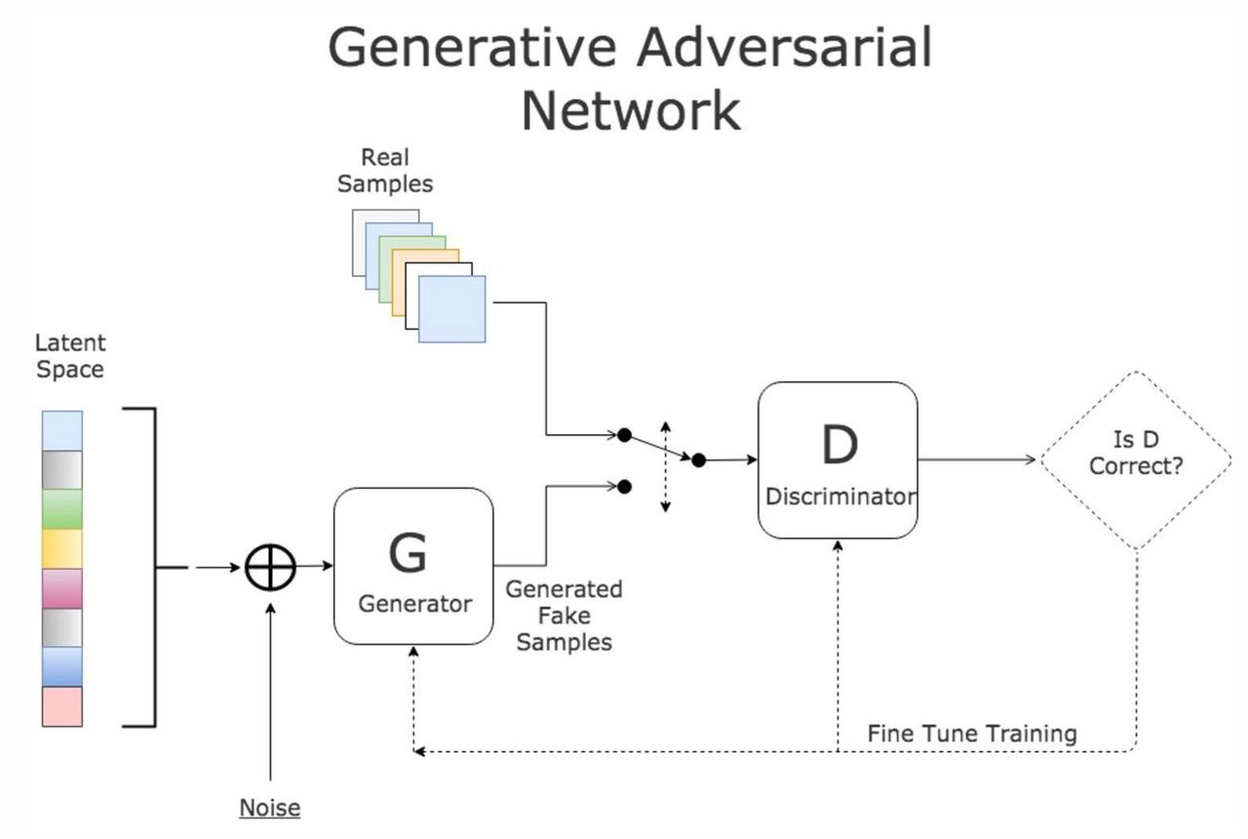
Applications of GANs
- Generating realistic human faces and artificial images.
- Image-to-image translation and photo enhancement.
- Creating synthetic training data for machine learning.
- Image restoration and resolution enhancement.
- Generating artwork, animations, and game assets.
2. Types of GANs
Several types of GANs have been developed to improve image quality, training stability, and the ability to generate specific types of data.
1. Vanilla GAN: The basic GAN architecture that uses a Generator and a Discriminator. It is mainly used to understand the fundamental working of adversarial learning.
2. Deep Convolutional GAN (DCGAN): Uses convolutional neural networks to generate images. It is commonly used for image generation and feature learning.
3. Conditional GAN (cGAN): Generates data based on additional information, such as a class label or text description. For example, it can generate an image of a cat when given the label “cat.”
4. Wasserstein GAN (WGAN): Uses the Wasserstein distance to improve training stability and reduce problems such as mode collapse.
5. CycleGAN: Converts images from one domain to another without requiring paired training examples. For example, it can transform horse images into zebra images.
6. Pix2Pix GAN: Performs image-to-image translation using paired training data, such as converting sketches into realistic images.
7. Super-Resolution GAN (SRGAN): Enhances low-resolution images by generating sharper, high-resolution versions.
8. StyleGAN: A GAN architecture developed by NVIDIA that provides detailed control over the visual features and styles of generated images, particularly human faces.
3. StyleGAN
StyleGAN is an advanced type of Generative Adversarial Network developed by NVIDIA. Its first version was introduced in 2018 and published in 2019. StyleGAN is especially well known for generating highly realistic human faces that may be difficult to distinguish from photographs of real people.
Unlike traditional GANs, StyleGAN provides better control over the features and appearance of generated images. It uses a mapping network and a synthesis network to control different visual characteristics, such as facial shape, hairstyle, skin texture, lighting, and background.
Architecture of StyleGAN
1. Mapping Network: Converts a random latent vector into an intermediate latent representation. This representation helps control the styles used to generate an image.
2. Synthesis Network: Generates the image progressively, starting from a low-resolution representation and moving towards higher resolutions.
3. Adaptive Instance Normalization (AdaIN): In the original StyleGAN, AdaIN is used to inject style information into different layers of the synthesis network, influencing the appearance of the generated image.
4. Noise Injection: Adds random noise at different layers to create fine details, such as skin texture, hair strands, and small visual variations.
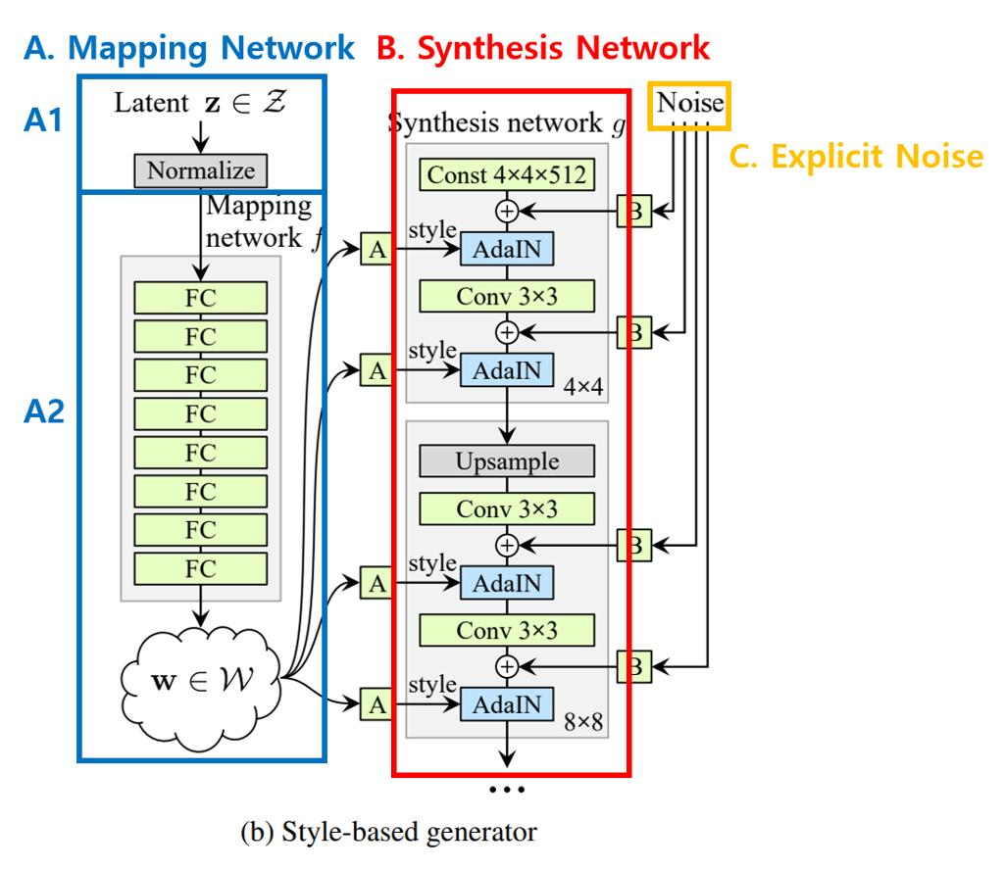
Types and Versions of StyleGAN
- StyleGAN: Introduced style-based image generation and control over visual features.
- StyleGAN2: Improved image quality and reduced certain visual artifacts present in the original version.
- StyleGAN3: Improved the consistency of generated images under movement and transformations, making it useful for animation and video-related applications.
Applications of StyleGAN
- Generating realistic human faces that do not belong to real people.
- Creating digital characters for games and films.
- Producing artistic portraits and creative designs.
- Editing facial attributes and visual styles.
- Generating synthetic datasets for research and computer vision.
Conclusion
GANs are powerful deep learning models that generate realistic synthetic data through competition between a Generator and a Discriminator. Different GAN architectures are designed for specific tasks, including image translation, image enhancement, and conditional generation. StyleGAN is a major advancement in GAN technology because it offers high-quality image generation and greater control over visual features. Its applications extend to entertainment, digital art, computer vision, and synthetic data generation.

